Detecting Face Mask using AI, ML and Deep Learning for COVID-19 Prevention

Toshiba Ansari (20BCS6671), Abhishek Singh (20BCS6673), Rahul Goyal (20BCS6713) and Pushp Jain (20BCS6706), AIT-CSE Dept., Chandigarh University, Mohali, Punjab, 140413

**Abstract**

Since the infectious coronavirus sickness (COVID- 19) was initial rumored in urban center. COVID-19 epidemic has fleetly discontinuous our every-day lives moving the international trade and movements. However, carrying a mask that stops the transmission of droplets within the air associated maintaining an acceptable physical distance between folks, and reducing shut contact with one another will still be useful in combating this pandemic. However, guaranteeing all folks wear facemask isn't a straightforward task. The purpose of the proposed model “Detecting Face Mask using Artificial Intelligence, Machine Learning and Deep Learning for COVID-19 prevention” is to create a tool that identifies the image of a human that can calculate the probability that he/she wearing a mask or not using tools like TensorFlow, Keras, OpenCV and Scikit-Learn. If there’s a violation within the scene or public places, it will generate an alarm. The system performance is evaluated in terms of precision-recall, F1-score, support, sensitivity, specificity and accuracy that demonstrate the sensible pertinency. The system performs with F1-score of 99%, sensitivity of 99%, specificity of 99% associated an accuracy of 100%. This may be used with the prevailing embedded camera infrastructure to alter these analytics which may be applied to numerous verticals, furthermore as in associate building or at airports terminals/gates.

***Keywords- Artificial Intelligence, Machine Learning, Deep Learning, Face mask, Tenser Flow, COVID-19, F1-score, Open CV, Scikit-Learn.***

**Introduction**

The COVID-19 pandemic emerged in December 2019 in metropolis town within the Hubei province of central China. Perceptive the virus’s growth and unfold among humans, the World Health Organization declared the corona virus (i.e., Sars-CoV-2) to be a world pandemic in March 2020. This pandemic has devastating effects on societies and economies round the world inflicting a world health crisis [1]. It's associate degree rising metastasis communicable disease caused by Severe Acute metastasis Syndrome Coronavirus2. Everywhere on the planet, particularly within the third wave, COVID-19 has been a major health care challenge [2]. Several shutdowns in numerous industries are caused by this pandemic. According to the centers for Disease Control and Prevention (CDC), corona viral infection is transmitted predominantely by respiratory droplets made once individuals breathe, talk, cough, or sneeze [2] with common drop size 5–10’m however aerosol emission will increase once humans speak and shout loudly [3]. People with COVID-19 have had a good scope of symptoms reported like shortness of breath or issue in respiratory. Elder individuals having respiratory organ unwellness are at higher risk [4] of obtaining corona virus than most. Therefore, to forestall speedy COVID-19 infection, several solutions, like confinement and lockdowns, are recommended by the bulk of the world’s governments. It's true that COVID-19 could be a world pandemic and have an effect on many domains. The importance of sporting masks be reducing vulnerability of risk from a pestilent individual throughout the “pre-symptomatic” amount to restrain the spreading of the virus. More than five million cases were infected by COVID- 19 in less than 6 months across 188 countries. The virus spreads through close contact and in crowded and overcrowded areas. We can tackle and predict new diseases by the help of new Technologies such as artificial intelligence, IOT, Big data, and Machine learning.

It created a path for researchers in engineering. We've got seen multiple analysis topics, like making new automatic detection ways of COVID-19 and detection individuals with or while not masks. Before corona virus, some individuals place masks to shield themselves from pollution, whereas others place face masks to cover their faces and their emotions from others. Protection against corona virus could be a necessary counter live, per the WHO [1]. Indeed, sporting a mask is a good methodology of obstruction 80 of all metastasis infections [2]. Several organizations enforce mask rules for the non-public protection. Checking manually if people coming into a corporation are sporting masks is cumbersome and probably conflicting. It's crucial to watch mask usage across numerous regions to adequately offer info to policy manufacturers and epidemiologists UN agency project the progress of the irruption. As a results of COVID-19, the necessity has arisen to develop associate degree economical mask detection algorithmic rule to trace mask usage in inhabited areas. A way to see mask usage while not any spreading the virus is to watch the publicly accessible webcams in bulk and examine the faces for masks.

A mask detector system is enforced to envision this. Mask detection means that to spot whether or not someone is sporting a mask or not. the primary step to acknowledge the presence of a mask on the face is to observe the face, that makes the strategy divided into 2 parts: to observe faces and to observe masks on those faces. Deep learning has been won’t to establish UN agency isn't sporting the facial mask mistreatment Convolutional neural network. It's various applications, like autonomous driving, education, police work, and so on [5]. The approach is ascendable, safe to execute, and provides a much bigger image of mask usage within the world. There are several detector systems developed round the world and being enforced. However, all this science desires optimization; a stronger, a lot of precise Detector, as a result of the world cannot afford to any extent further increase in corona cases. Considering AI legal issues and advantages in combating COVID-19 pandemic, AI technique-based solutions are still associate degree open window for development and legal interpretation [6]. the sphere of AI (AI) analysis has advanced considerably in recent years, particularly within the space of machine learning. Any fresh developed technology is indivisible from the term AI. While not AI it's terribly tough today to form any vital progress in terms of technical innovation. AI is being thought of because the next huge issue that may amendment the world hugely.

**Literature Review**

Gagandeep Kaur, Ritesh Sinha, Puneet Kumar Tiwari, Srijan Kumar Yadav, Prabhash Pandey, Rohit Raj, Anshu Vashisth, Manik Rakhra (2021) has revealed a paper on mask recognition system using CNN model [7]. This technique is often enforced within the retail retailers and therefore the result is often seen on the digital and promotional screens. Though many case studies are listed to demonstrate the period situation of the COVID-19 issue, the preparation of the systems in period is extraordinarily tough. Developing a system that's adaptative to any or all contexts and surroundings is turning into a problem.  
If we have a tendency to contemplate the price estimation for implementing the project, it'll be virtually of no price as most of the metropolitan cities have already got cameras put in publicly places. Camera; that is the solely main demand of the planned model is already on the market. Their model is predicated on neural networks. A neural network may be a network OR circuit of neurons, that is additionally referred to as an artificial neural network and is formed of artificial neurons or nodes. This model is often used for various functions associated with image process in neurobiology mistreatment dataset containing pictures associated with that task. This approach provides not solely helps in achieving high exactness however additionally enhance the face detection tempo significantly. The system is often applied in several areas like subway stations, markets, schools, railway stations and lots of alternative huddled places to observe the group and to confirm that each one is sporting mask. Finally, this work is often used for future researchers and enthusiasts. Firstly, this model is often employed in any high-definition camcorders, this can check that that this model isn't restricted to solely mask detection system. Secondly, this will be used for biometric scans with a mask on the face.  
  
Abd El-Aziz, Nesrine A. Azim, Mahmood A. Mahmood and Hamoud Alshammari has revealed a paper on deep learning model for mask detection (2021) [8]. The system will expeditiously discover faces that area unit partly occluded (either with a mask or hair or hand). Supported the occlusion degree of 4 regions (nose, mouth, chin and eye) it differentiates between annotated mask and face lined by hand. Therefore, a mask covering the face absolutely together with nose and chin can solely be treated as “with mask” by the model. The most challenges two-faced by the tactic primarily comprise of variable angles and lack of clarity. The movement of blurry faces within the video stream makes it tougher. However, following the trajectories of many frames of the video helps to form a far better call – “with mask” or “without mask”.  
In this paper, they in brief explained the motivation of the work 1st. Then, they illustrated the educational and performance task of the model. Using basic ML tools and simplified techniques the tactic has achieved fairly high accuracy. In future, the model is often extended to discover if an individual can wear the mask properly (as educated by WHO) and additionally to discover the sort of mask.  
  
Safa Teboulbi, Seifeddine Messaoud, Mohamed Ali Hajjaji and Abdellatif Mtibaa (2021) has planned a paper on period Implementation of AI-Based mask Detection and Social Distancing measuring System for COVID-19 prevention [9]. This work reviewed, firstly, several Analysis works that obtain to surround COVID-19 natural event. Then, it processed the essential ideas of deep CNN models. After that, this paper reproduced the coaching and testing of the foremost used deep pretrained-based CNN models (DenseNet, InceptionV3, MobileNet, MobileNetV2, ResNet-50, VGG-16, and VGG-19) on the mask dataset. Finally, and when evaluated the numerical results, best models are tested on an embedded vision system consisted of Raspberry Pi board and digital camera where efficient real-time deep learning-based techniques are implemented with a social distancing task to change the method of detective work cloaked faces and desecrated or maintained distance between peoples.  
This embedded application are often employed in any operating atmosphere like public place, station, company atmosphere, streets, searching malls, and ex- amination centers, wherever accuracy and exactness are extremely desired to serve the aim. In future works, they're going to exploit this system on good sensors or connected RP nodes that may be thought-about as an Edge Cloud to gather multimedia system knowledge, e.g., an autonomous drone system, which may give capture (by the camera) of the detected objects from totally different angles and send them to the Edge Cloud system to be analyzed.  
  
Eashan Adhikarla and Brian D. Davison (2021) has planned a paper on mask Detection on Real-World Webcam images [10]. They conferred a new webcam-based dataset that reflects real-world complexness. They tested 12 totally different models to know their effectivity. They additionally used 3 models to label the remaining knowledge to match foreseen mask usage trends and with another supply of information. The WFM dataset is efficacious for potential COVID-19 connected studies and offers diversity for AI-related datasets as this is often the primary digital camera dataset with face masks that has been collected. The dataset provides a real-world challenge for developing higher AI models, incorporating real-world masks for face detection and face mask detection tasks, and may be a collection of 10 months of captured pictures, a tiny low portion of that has been hand-labeled. Normally mask detection algorithms area unit divided in 2 tasks; (1) detective work the faces in an exceedingly given image, and (2) then classifying the image as a cloaked or no-masked face that's a binary classification task. They have a tendency to outline a further third category to replicate uncertainty or once the mask isn't worn properly. This work may be a kind of image classification and extraction. Their system is often employed in any public place, restaurant, airport etc.

Mr. Kalla. Kiran, Bokka Vamsi Kiran, Devarapalli Cheswanth Sai, Gaggala Vijay Vamsi, Pitta Rani Salomi (2021) has planned a paper on mask detection using machine learning [11]. The experimental analysis shows that the planned technique will be with success exploited for mask violation detection. It's a true time package application which may be deployed in good cc tv police investigation, public areas like airports, malls, etc. wherever mask is dominant. Simply, the package will be extensible to figure together with different IOT devices to deny allow or closing doors at company workplace. What is more, we have a tendency to highlight that it's operating additionally on device with restricted machine capability and it's able to method in real time pictures and video streams, creating their proposal applicable within the world. Taking in to account higher than mentioned details, they will build the conclusion that the Mask detection project works in real time and be terribly helpful in gift scenario. This application is put up using python, python IDLE.

The project proposed by us use OpenCV, Tensor Flow and deep learning to detect the face mask. Our goal is to create a custom deep learning model to detect whether a person is wearing a mask or not. This system first detect the image of a person. Then it will detect the COVID-19 face mask on the person’s face. The classifier that obtained is ~98% accurate. Then it will classify whether the person is wearing a mask or not. If not then it will generate an alert. The main purpose of this system is we use this system in primary schools.

**Proposed Work**

The proposed model is based on Machine Learning, Artificial Intelligence and Deep Learning.

"AI" or "Artificial intelligence" is about making a computer that can mimic human intelligence and mimic actions. The human-like machine is the ai. AI is rapidly becoming a popular field of computer science and has transformed human life in many ways. AI includes Natural Language Processing (NLP), Robotic, Expert System etc. AI techniques include sensory networks, cognitive intelligence, evolutionary computing and mixed artificial intelligence. Some of the ai apps

• Sick housing

• Finance.

***Some of the challenges of ai***

• Model durability

• Model transparency

• Disclosure of information

• Extrapolation

• Uncertainty

“ML” or “Machine Learning” is a field of computer science in which a machine learns from previous experiences without human intervention. Machine learning is everywhere, from our smartphone to our car. The snapchat filters we use, Alexa, google assistant, google maps are all ML apps.

***Machine learning involves three types of activities:***

• Supervised reading - Input and output system.

• UnSupervised reading - Installed program only.

• Reinforcement learning - A system that is agent-oriented and environmentally friendly.

***Some of the ML applications***

• Filter spam email

• Online fraud detection

• Forecast

• Speech recognition

• Self-driving cars

• Photo recognition etc.

***Some of the challenges of ML are***

• Implementation of state-of-the-art production technology

• Variety, volume, authentication for big data

"Deep Learning" is a subset of Machine Learning. It is a field that captures past knowledge and provides output using advanced algorithms. Deep Learning uses sensory networks designed to mimic human behavior. Deep Reading uses two layers which is why, this name got its name.

***Some of the Advanced Learning applications are***

• Chatbot

• Health care

• Automatic translation

• Voice search

***Some of the challenges of In-depth Learning are***

• Neural Network Disruption

• Ensuring Data Quality

• Data Security

• Production Garde AI

In order to overcome the problems of the existing system, the proposed system has been modified. This project aims to ensure that people adhere to basic safety principles. This is done by creating a face mask search system. The proposed approach is divided into two phases. We will add two more Python texts.

• Get COVID-19 face mask on photos

• Get a COVID-19 face mask in real-time video streaming

Figure 1 shows the whole proposed framework, in this paper, which consists of two main blocks.

**1. Training:** We load our face mask discovery data, train the model using Keras / TensorFlow on this database, and assemble the face mask detector on disk.

**2. Deployment:** Once the mask detector is trained, we can proceed to loading the mask scanner, scan the face, and classify each face as a_mask with or without a_ mask.

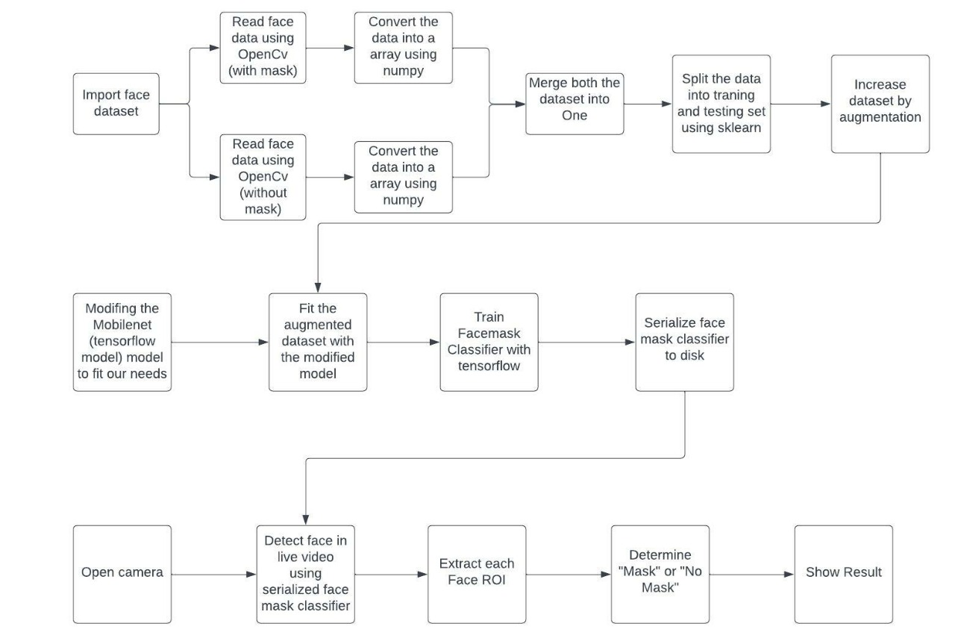

The dataset is taken from arxiv.org and consists of 2,309 images belonging to two classes:

* with_mask: 1125 images
* without_mask: 1184 images

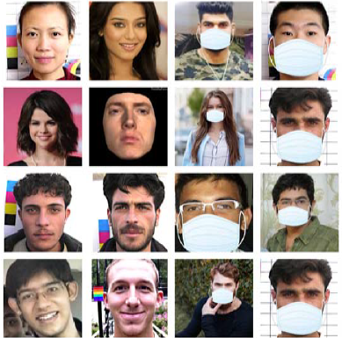

Fig1.

We can take normal images of the people and then by using computer vision we can add face mask to their face. This is easy for doing by using face recognition that helps us to infer the location of facial structures like

* Eyes
* Eyebrows
* Nose
* Mouth
* Jawline

For creating our own dataset, we need an image without mask. Then we apply face detection to get the location of bound box. Then we extract face region of interest. After that we apply facial landmarks. We need an image of a mask and by computing facial landmarks, the mask applied automatically on the image. We use Imutils for video streaming and it will automatically create a frame and open the camera for the user to detect whether the person is wearing a mask or not. We can also create confusion matrix, plots the graph or bar chart etc. by using matplotlib library that is used for data visualization. In this hard period, where mask is as important as oxygen, this project is very useful for safety of the people.

**Comparison Study**

|  |  |  |  |  |  |
| --- | --- | --- | --- | --- | --- |
| **Ref** | **Model Used** | **Image Type** | **Year** | **Accuracy** | **Optimization** |
| [7] | CNN Model | RGB Image | 2021 | 99.15% | YES |
| [8] | Deep Learning Model | RGB Image | 2021 | 95.77% | YES |
| [9] | CNN Model | JPEG Image | 2021 | 100% | YES |
| [10] | CNN Model | JPEG Image | 2021 | 92.64% | NO |
| [11] | Deep Learning & Machine Learning | JPEG Image | 2021 | 95% | YES |

**Conclusion**

Steps must be taken to control the spread of the COVID-19 epidemic. This facial mask recognition program is an excellent and effective way to do that. This program will separate people from the masked mob. The identification of people, which violates the principles of COVID increases the flexibility of the face mask system for publicity. Used properly, the face mask system can be used to ensure our safety and that of others as well. This method not only helps to achieve high accuracy but also improves the visual acuity significantly. The system can be used in many places such as municipal stations, markets, schools, railway stations and many other crowded places to monitor the crowd and ensure that everyone wears a mask. Finally, this work could be used by future and enthusiastic researchers. First of all, this model can be used on any high-definition cameras, this will ensure that this model is not limited to the face mask detection system. Second, this can be used for biometric scanning with a face mask.

Further we will work to classify the faces into three categories that is, with mask, without mask, Improper mask instead of just the two with and without mask class by adding datasets with images of people wearing masks not covering their noses properly and also to detect the masked face using the Face-Net model of Convolutional Neural Network.

So as to further improve our model and add marking attendance feature in it by detecting the face even when the mask is on.

**References**

[1] M. Loey, G. Manogaran, M.H.N. Taha, and N.E.M. Khalifa, “A hybrid deep transfer learning model with machine learning methods for face mask detection in the era of theCOVID-19 pandemic,” *Measurement*, vol.167, Article ID 108288,2021.

[2] Z. Wang, P. Wang, P. C. Louis, L. E. Wheless, and Y. Huo, “Wear mask: fast In-browser face mask detection with serverless edge computing for COVID-19,” 2021, https://arxiv. org/abs/2101.00784.

[3] S.K. Dey, A. Howlader, and C. Deb, “Mobile Net mask: a multi-phase face mask detection model to prevent person-to- person transmission of SARS-CoV-2,” in *Proceedings of International Conference on Trends in Computational and Cognitive Engineering*, pp.603–613, Springer, Dhaka, Bangladesh, December2021.

[4] “Coronavirus Disease 2019 (COVID-19) – Symptoms”, Centers for Disease Control and Prevention, 2020. [Online]. Available: <https://www.cdc.gov/coronavirus/2019-ncov/symptomstesting/symptoms.html.2020>

[5] M. Jiang, X. Fan and H. Yan, “Retina Mask: A Face Mask detector”, arXiv.org, 2020. [Online]. Available: <https://arxiv.org/abs/2005.03950.2020>

[6] M. Perc, M. Ozer, and J. Hojnik, “Social and juristic challenges of artificial intelligence,” *Palgrave Communications*, vol.5, no.1, pp.17, 2019.

[7] Gagandeep Kaur ∗, Ritesh Sinha, Puneet Kumar Tiwari, Srijan Kumar Yadav, Prabhash Pandey, Rohit Raj, Anshu Vashisth, Manik Rakhra “Face mask recognition system using CNN model”, 2021.

[8] A. A. Abd El-Aziz††, Nesrine A. Azim††, Mahmood A. Mahmood†, ††, and Hamoud Alshammari† “A Deep Learning Model for Face Mask Detection”, 2021.

[9] Safa Teboulbi, Seifeddine Messaoud, Mohamed Ali Hajjaji and Abdellatif Mtibaa “Real-Time Implementation of AI-Based Face Mask Detection and Social Distancing Measuring System for COVID-19 Prevention” Article id- Volume 2021, Article ID 8340779, 21 pages, 2021.

[10] Eashan Adhikarla Brian D. Davison “Face Mask Detection on Real-World Webcam Images”, 2021.

[11] Mr. Kalla. Kiran, Bokka Vamsi Kiran, Devarapalli Cheswanth Sai, Gaggala Vijay Vamsi Pitta Rani Salomi “FACE MASK DETECTION USING MACHINE LEARNING”, 2021.